Mind & Body Activities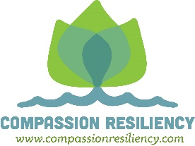
Your mind and body are connected. These activities reduce stress and ground you into the present moment.
1. Yoga
2. Tai Chi
3. Pilates
4. Relaxation Breathing
5. Progressive Muscle Relaxation/Body Scan
6. Massage
7. Reiki
8. Qi Gong
9. Mindful Walking
10. Swimming
11. Paddle Board
12. Gardening
13. Cycling
14. Fishing
15. Tennis
16. Running
17. Acupuncture
18. Visualization/Guided Imagery
19. Walking Labyrinth
20. HeartMath
21. Coloring
22. Art Therapy
23. Mindfulness
24. Prayer
25. Emotional Freedom Tapping
26. Singing
27. Floating
28. Dancing
29. Rocking/Swaying
30. Hula Hoop
31. Knitting, Crochet, Quilting

