Resources for Grieving During COVID-19

1. Anxiety the missing stage of grief, Claire Bidwell-Smith, 2018.

2. Centerforloss.com – This Pandemic of Grief – Center for Loss & Life Transition, Dr. Alan Wolfelt

3. Finding Meaning: The Sixth Stage of Grief, David Kessler, 2019.

4. Grief.com – COVID tab

5. Good-grief.org COVID Resources

6. Grief: Releasing Pain, Remembering Love & Finding Meaning Free Pop Up Private Facebook group with David Kessler.

7. Option B: Facing Adversity, Building Resilience and Finding Joy, Sheryl Sandberg & Adam Grant, 2017.

8. On Grief and Grieving: Finding Meaning of Grief Through the Five Stages of Loss, Elizabeth Kubler-Ross, 2014.

9. Refugeingrief.com

10. We are All Grieving: This is How We Get Through It – New York Times video, Esther Perel, Psychotherapist.

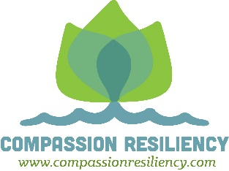
Kay Glidden – 7-2020

