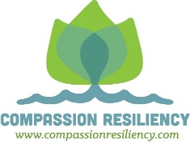
STAFF SELF CARE KIT IDEAS
Soothers
- Dark chocolate/hot chocolate
- Bubble bath
- Ice pack
- Sleep mask
- Magic wand/tiara
- Loofah sponge
- Play dough/silly putty
- Pipe cleaners
- Soothing Chamomile tea
- Stress ball
- Face mask
- Incense
- Essential oils
- Lavender soap/lotion
- Pocket stone
- Scented candle
- Coupon for one hour of wellness/self care time to use at their discretion
Distractors
- Laffy taffy/fire ball candy/Listerine strips
- Pedometer
- Puzzle or puzzle toy
- Pen and journal
- Nail file
- Bubbles
- Dynaband (rubber plastic band for stretching against resistance)
- Mandala coloring pages and colored pencils

